OVERALL PROGRAMME EVALUATION REPORT
Social Entrepreneurship Program (SEP)- START MASTERCLASS Uganda (26th January 2026 - 30th January 2026)
No. of Respondents: 17
No. of Participants: 111
Response Rate: 15%
--------------------------------------------------

Faculty Reports

Dr. James onyoin - Business Plan reviews
Evaluation Parameter | (%) Individual Score | (%) Programme Average
Punctuality (Commencement and Completion of Sessions) | 90 | 88
How well do you understand the core concepts presented? | 75 | 83
Rate your confidence in applying the new skills learnt | 65 | 78
Degree of Faculty preparedness for the sessions | 85 | 91
Content and methodology of the program | 80 | 87
Quality of class and group discussions | 70 | 82
The information presented in the course is relevant to my work (ministry) | 90 | 91
Average scores | 79 | 86

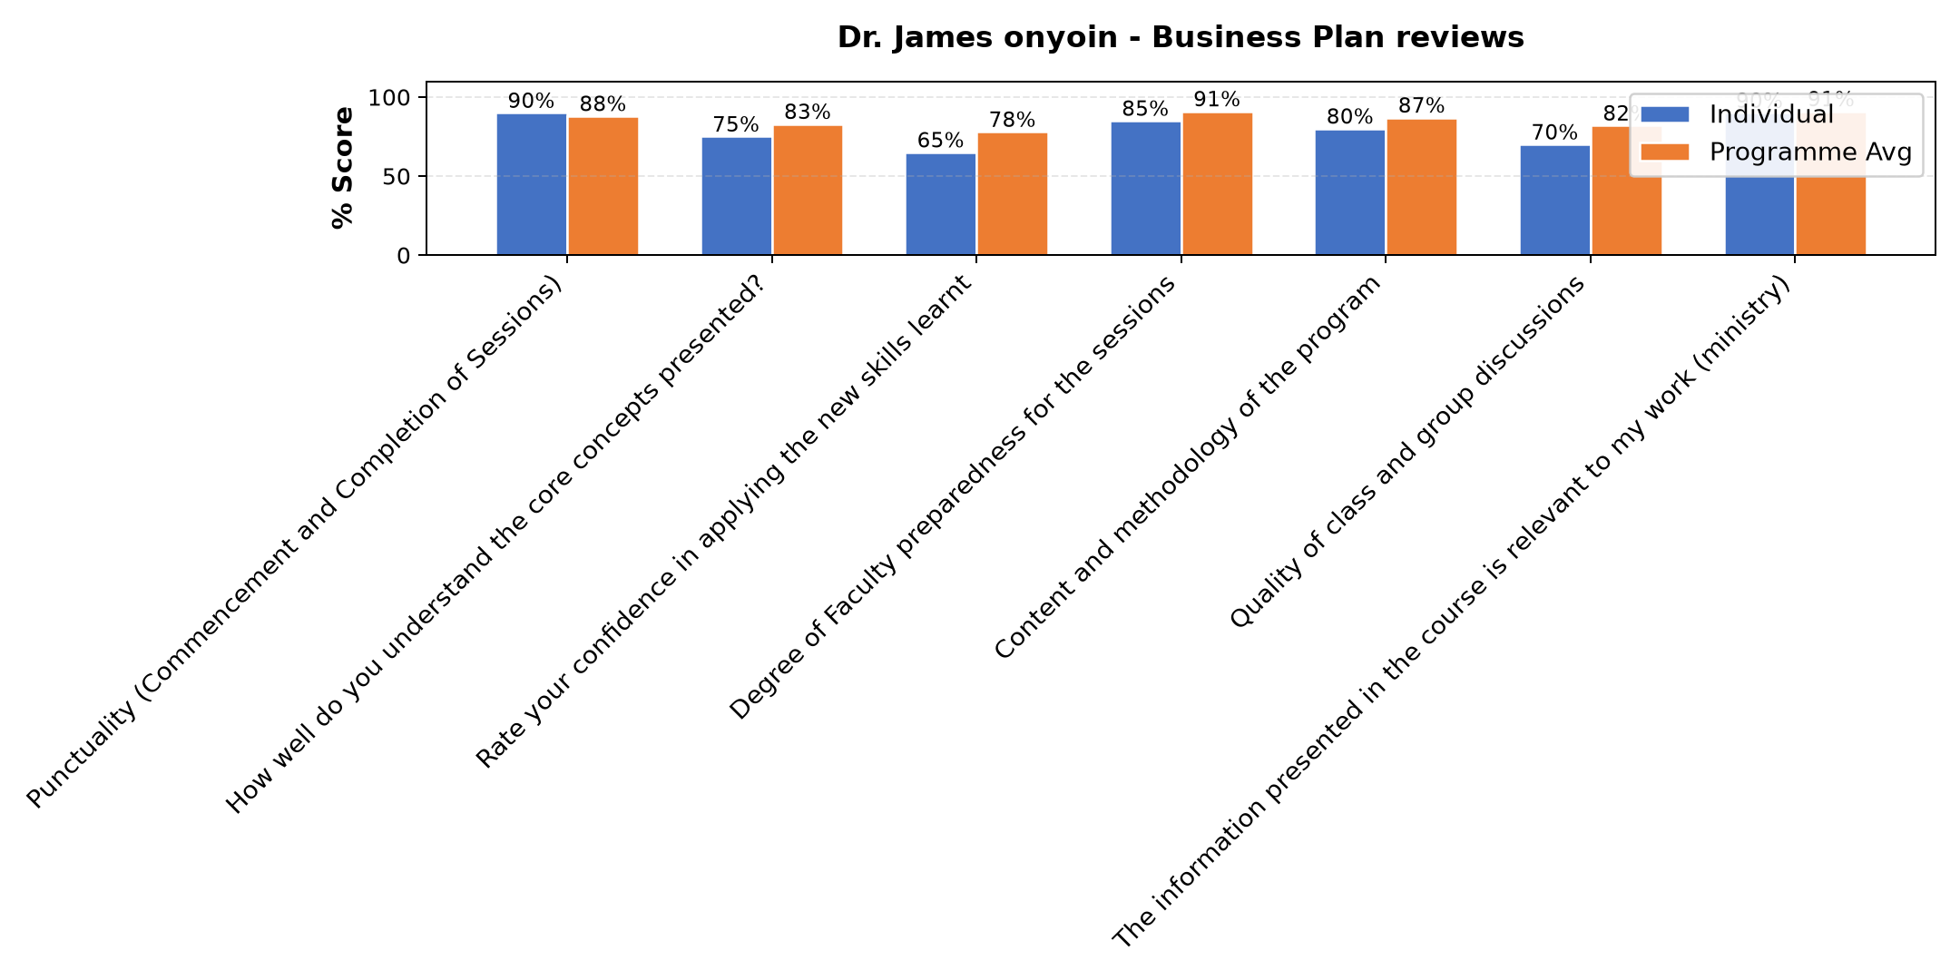

Comments & Feedback
- • Networking
- • Was not on site
- • Thank you so much for the opportunity you granted to us by sharing with us
- • Thank you for imparting us with the knowledge as well as our Enterprise is concerned

Loise Wanjiru Oburu - Customers and competitor evaluation/ Market potential evaluation/ Customers, competitor and market planning
Evaluation Parameter | (%) Individual Score | (%) Programme Average
Punctuality (Commencement and Completion of Sessions) | 89 | 88
How well do you understand the core concepts presented? | 84 | 83
Rate your confidence in applying the new skills learnt | 80 | 78
Degree of Faculty preparedness for the sessions | 96 | 91
Content and methodology of the program | 93 | 87
Quality of class and group discussions | 87 | 82
The information presented in the course is relevant to my work (ministry) | 91 | 91
Average scores | 89 | 86

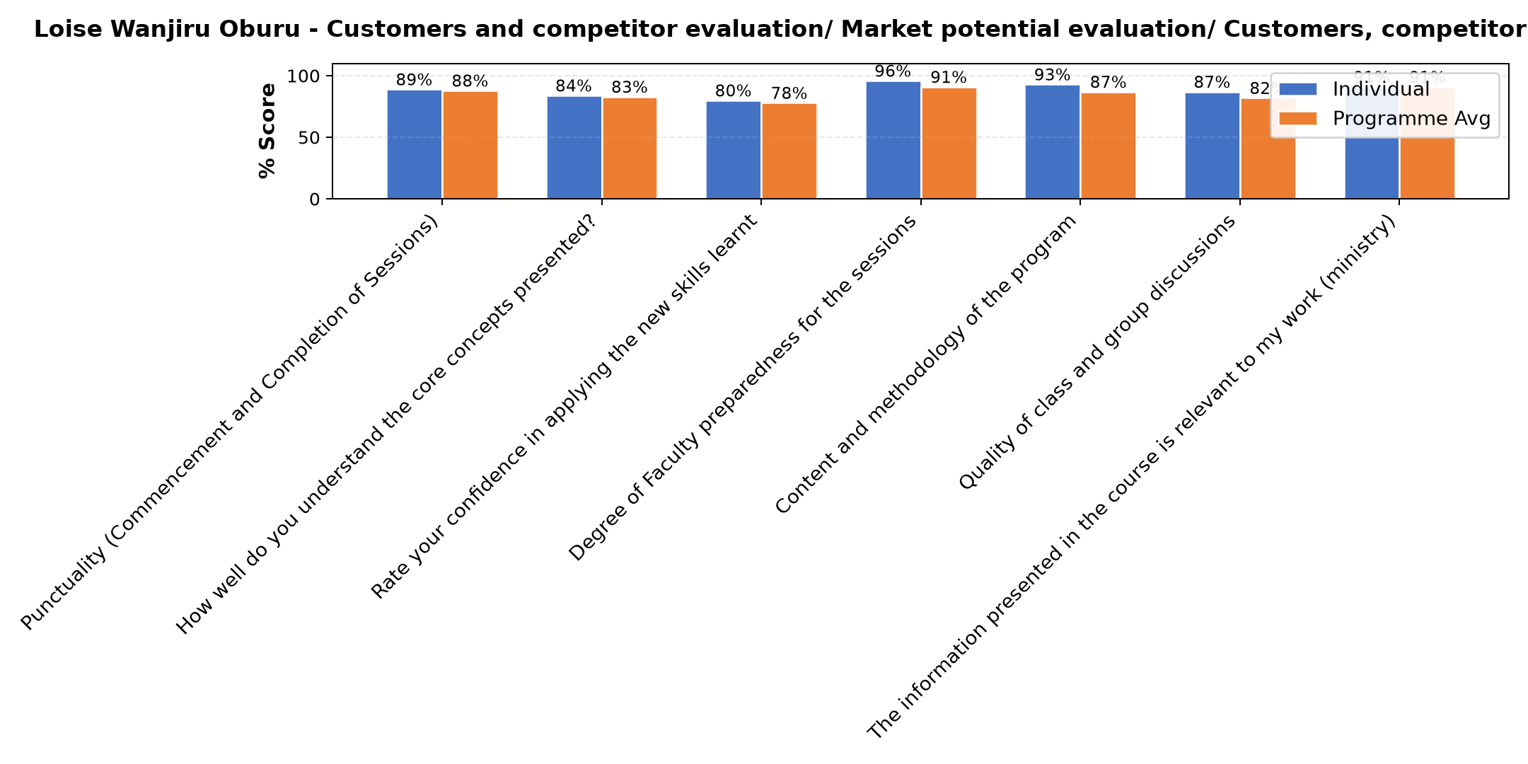

Comments & Feedback
- • No barriers
- • Network problems
- • Fear to apply knowledge
- • Not being close to the project
- • In case am not part or the leader of the enterprise since at times those leading it my take advises for granted.
- • I appreciate the faculty. All I have learned will help me at a personal level, but the ministry level, most of the time our hands are tied. We're now well equipped with entrepreneurship knowledge, but not our Spurious who are the decision makers. Most of the time our ideas are rubished. My suggestion is, our Superiors need this knowledge otherwise, we may not move anywhere
- • The major barrier that might bar application of the content learned is lack of capital.
- • The environment

Dr. Joan Wanjiku Ndung'u - Gitahi - Reflect on Vision and Mission/ Reflect on charism/ Identify alignment to social enterprise
Evaluation Parameter | (%) Individual Score | (%) Programme Average
Punctuality (Commencement and Completion of Sessions) | 80 | 88
How well do you understand the core concepts presented? | 85 | 83
Rate your confidence in applying the new skills learnt | 78 | 78
Degree of Faculty preparedness for the sessions | 93 | 91
Content and methodology of the program | 87 | 87
Quality of class and group discussions | 82 | 82
The information presented in the course is relevant to my work (ministry) | 88 | 91
Average scores | 85 | 86

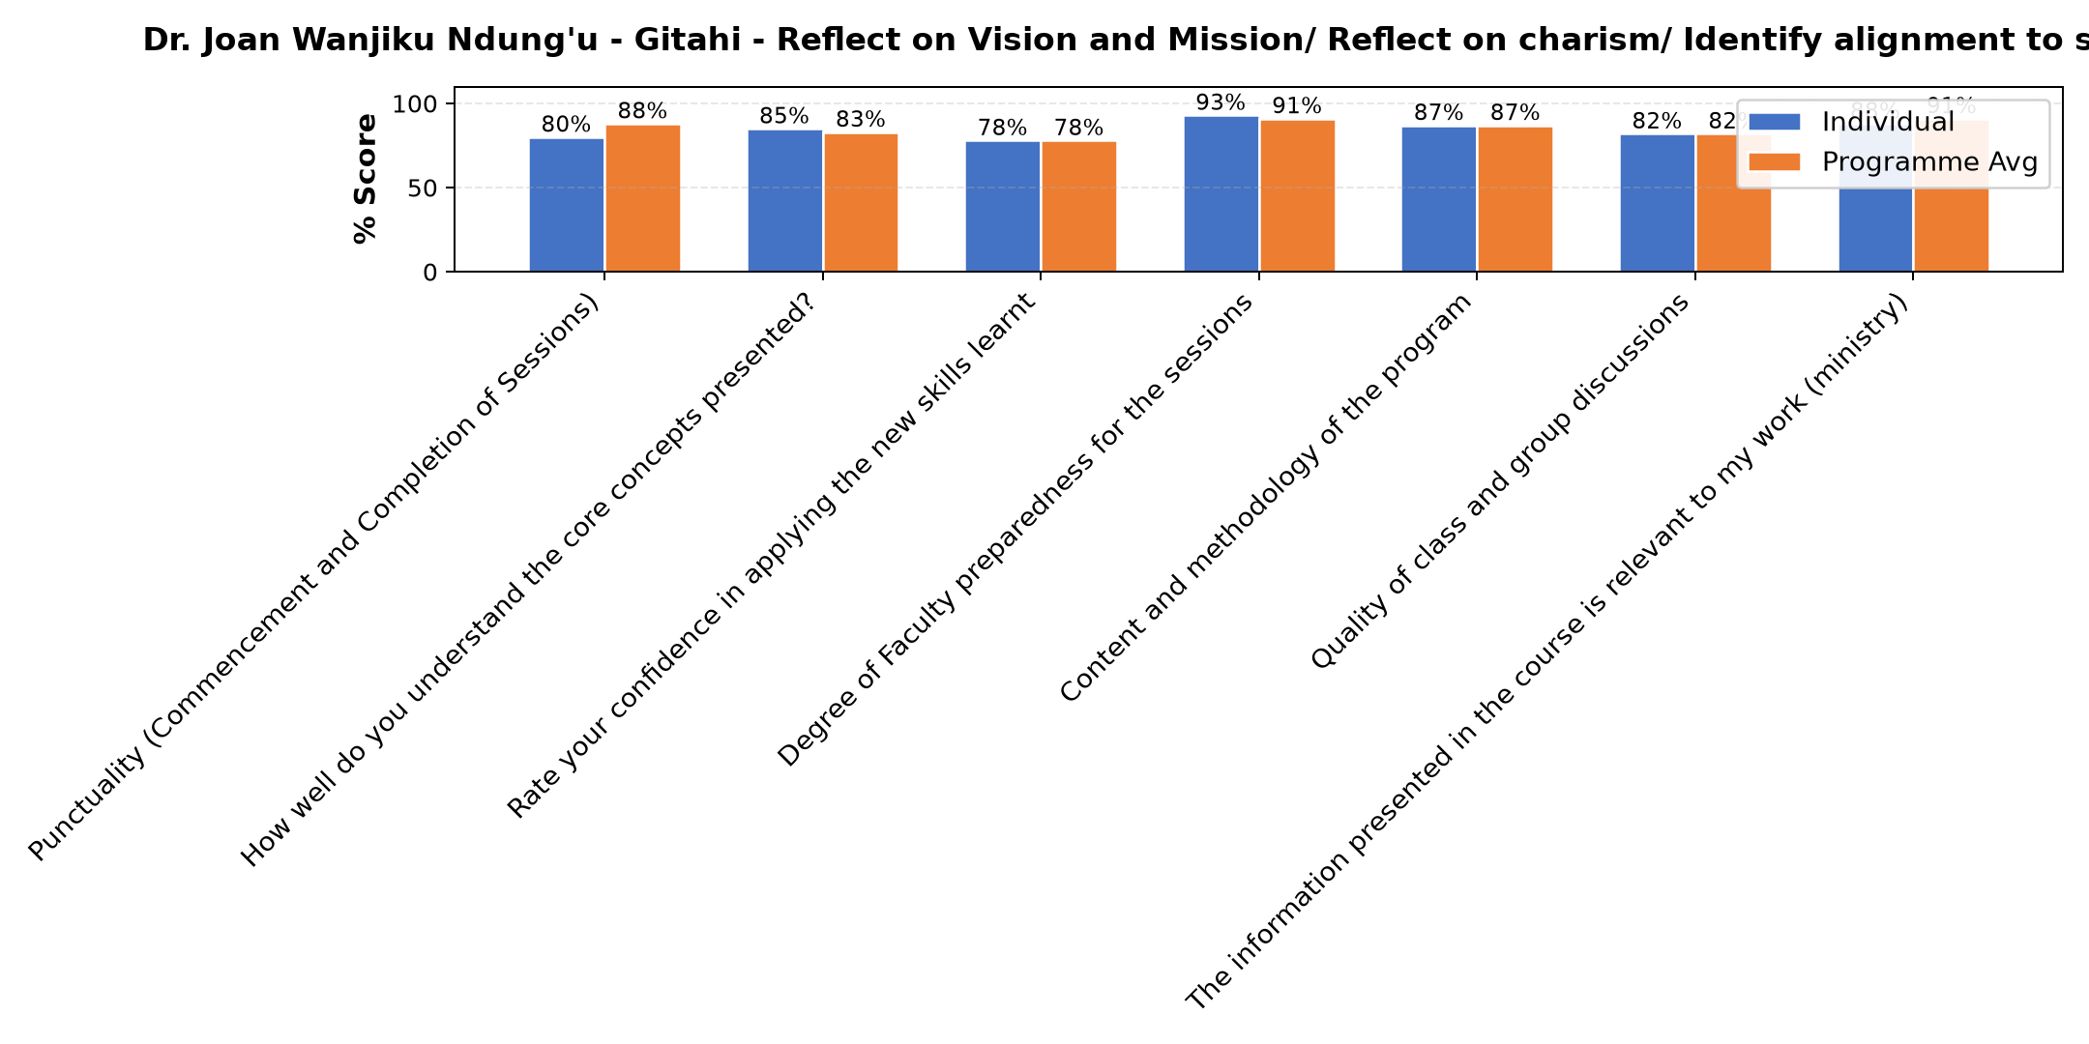

Comments & Feedback
- • Limited finances to carter for the targeted population
- • Lack of facilities like ours social enterprise we lacking the matinity ward and children's ward.
- • I went back for furthur studies
- • I went back for further studies
- • Absence on the ground
- • Organizational challenges. I could not concentrate since I was requested to go back to school
- • Transfer
- • Not operating that particular enterprise as a leader

Lena Gachoki - Reflection and leadership and teams (employees)
Evaluation Parameter | (%) Individual Score | (%) Programme Average
Punctuality (Commencement and Completion of Sessions) | 89 | 88
How well do you understand the core concepts presented? | 85 | 83
Rate your confidence in applying the new skills learnt | 84 | 78
Degree of Faculty preparedness for the sessions | 95 | 91
Content and methodology of the program | 91 | 87
Quality of class and group discussions | 84 | 82
The information presented in the course is relevant to my work (ministry) | 94 | 91
Average scores | 89 | 86

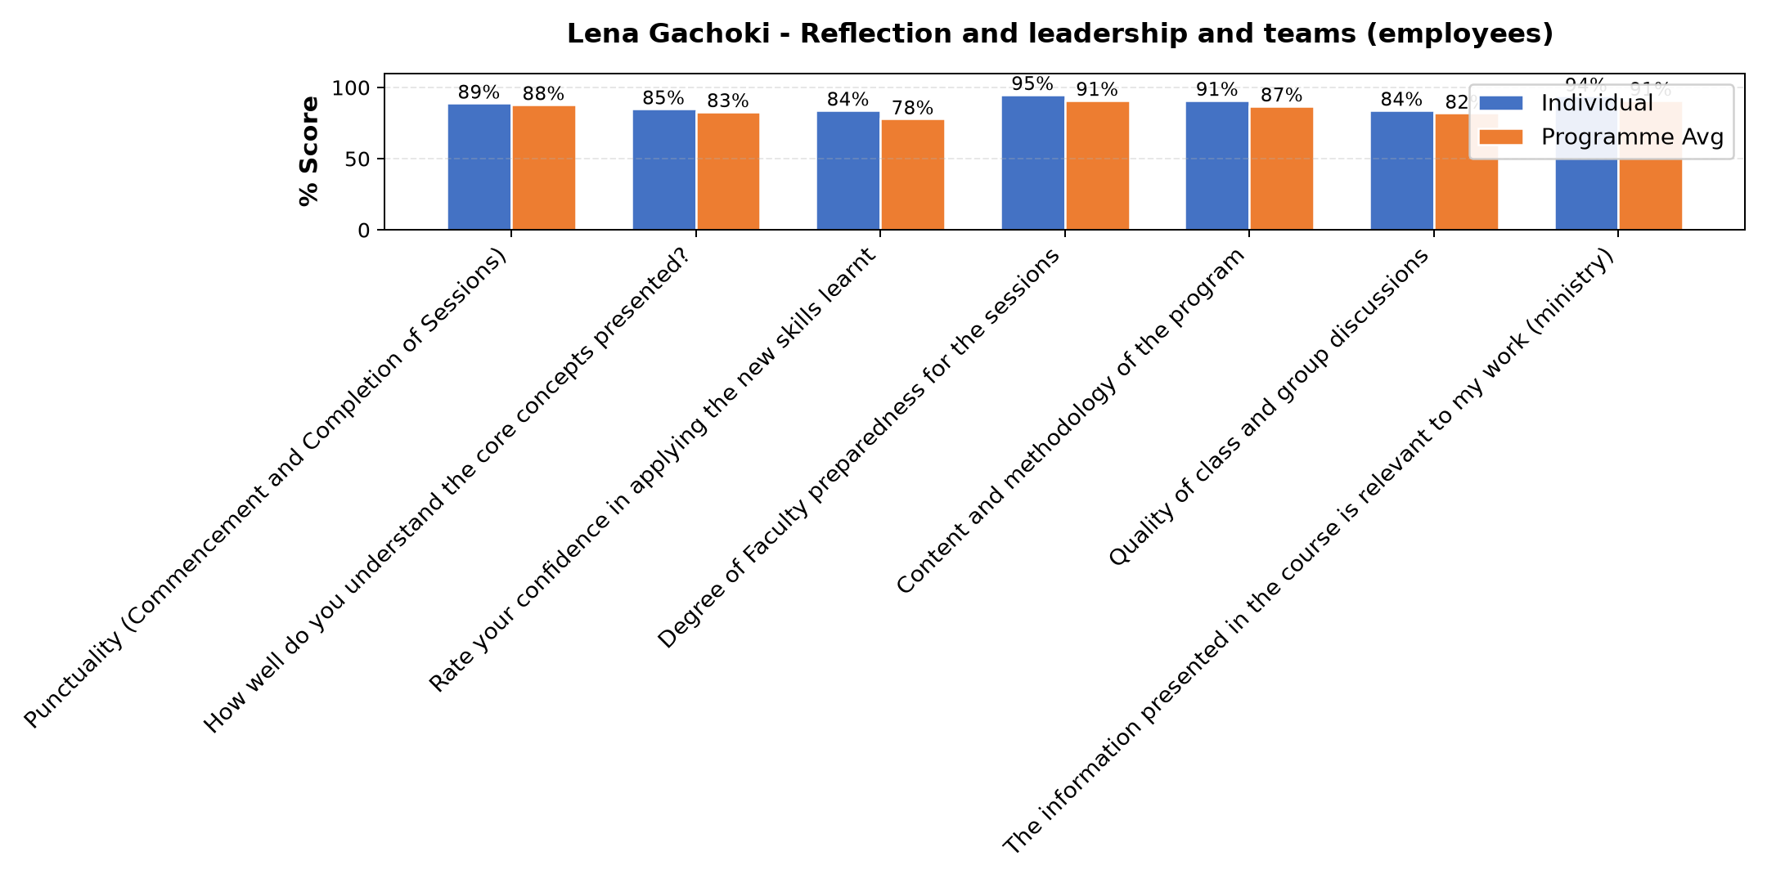

Comments & Feedback
- • Distance of the project
- • Distance
- • I think there are no obstacles to applying what I have learned in this presentation.
- • Lack of self review
- • I went back for further students , I could not fully practice my leadership skills as well as our social Enterprise is concerned.
- • Fear to take risk
- • Maybe just personal weaknesses which I have to work on
- • Lack of confidence
- • I went back for further studies

Dr. Tom Buringuriza - Reflection of SEP Learning
Evaluation Parameter | (%) Individual Score | (%) Programme Average
Punctuality (Commencement and Completion of Sessions) | 91 | 88
How well do you understand the core concepts presented? | 85 | 83
Rate your confidence in applying the new skills learnt | 83 | 78
Degree of Faculty preparedness for the sessions | 85 | 91
Content and methodology of the program | 86 | 87
Quality of class and group discussions | 86 | 82
The information presented in the course is relevant to my work (ministry) | 91 | 91
Average scores | 87 | 86

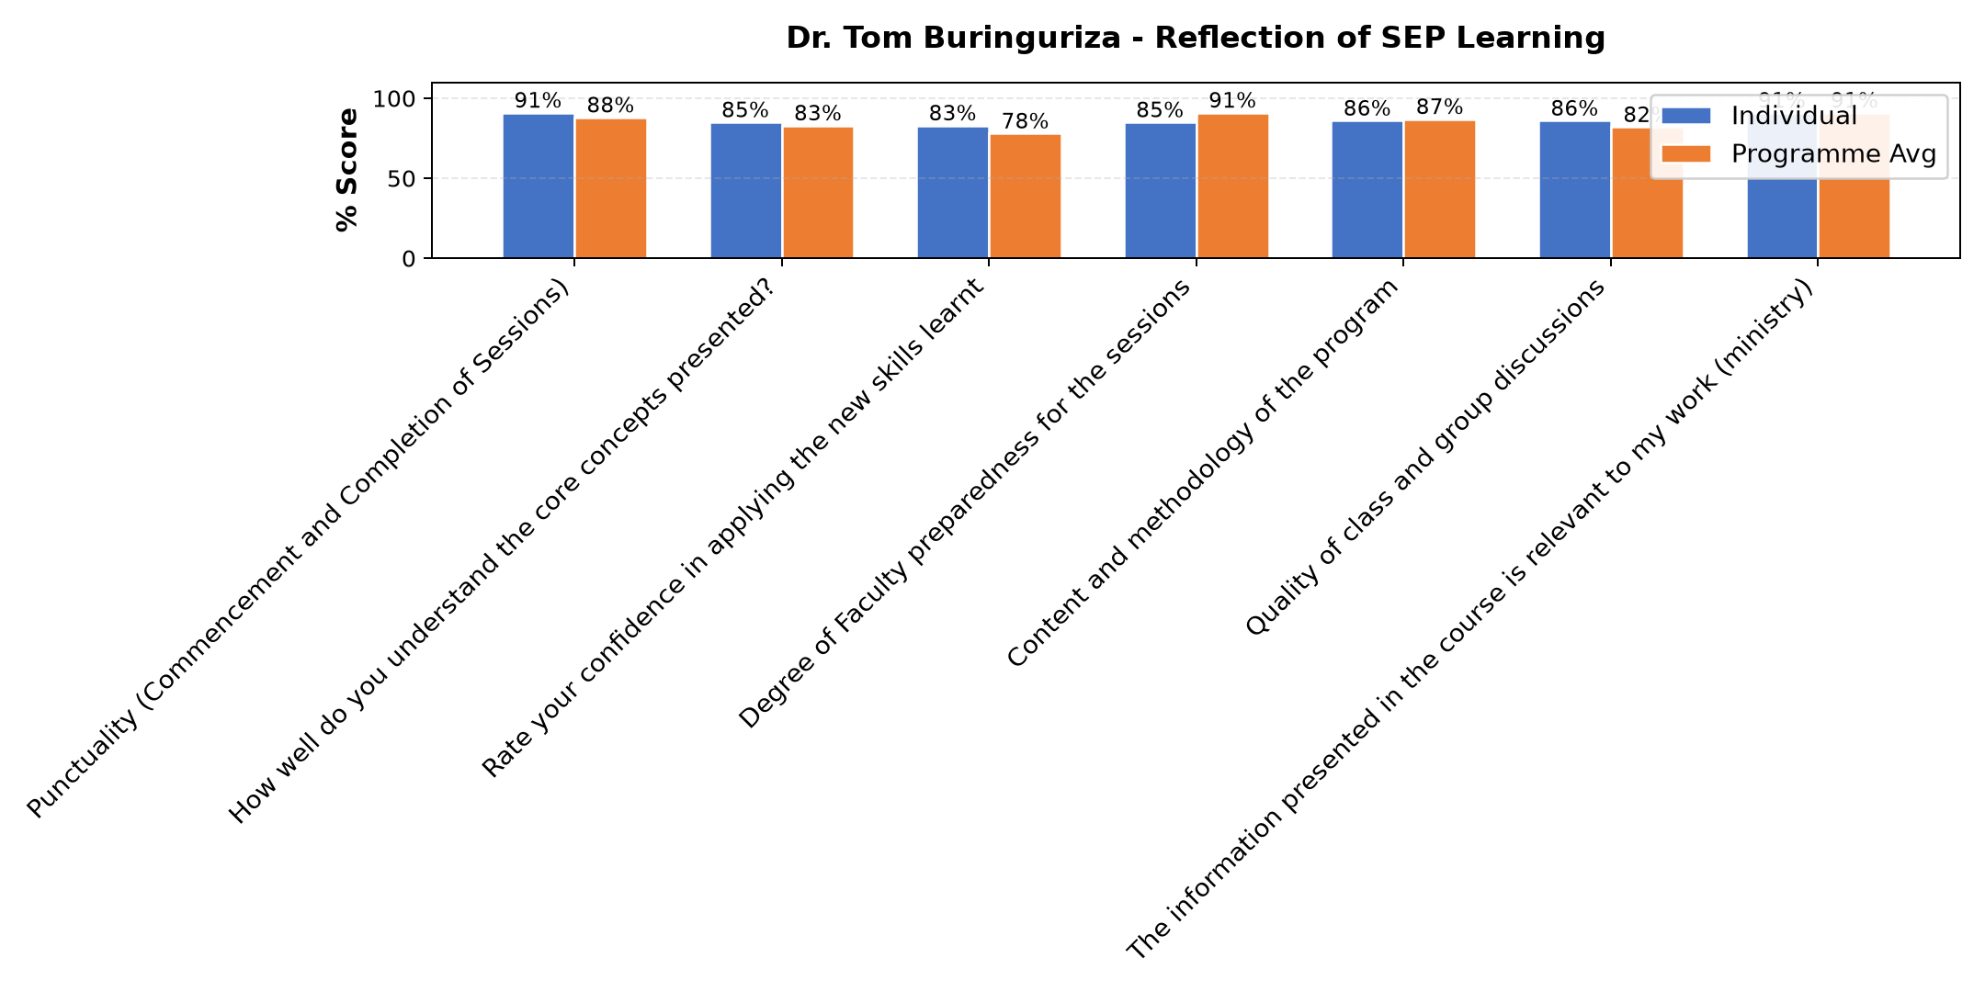

Comments & Feedback
- • Not performing my duties with in the enterprise and to some extent inadequate resource
- • Organizational structure, as was selected to be a project manager but I could not contrate since the Superiors of the congregation gave me a chance to go back to school so balancing the two became a problem
- • Organizational structure issues, i was requested by the superior of the congregation so balancing the role of the project manager and being a student at the same time being student became a challenge to me
- • Language barrier
- • Too much work in ministry, however with proper planning it can make work easier.
- • Being far from the social enterprice.
- • limited resource personnel as we make movements to the villages
- • Maybe if I get a transfer and I don't find the same enterprise where I am assigned.
- • Went back for further studies
- • Skills and experience
- • Net work and internet connections
- • Lacked enough time since I was anged with studies

Department Reports

Are there any other comments and/or suggestions that you may want to add?

Comments & Feedback
- • We missed some of the important things because of the network
- • Thank you ACWECA, thank you Strathmore for commitment towards seeing sisters projects succeeding. May the good Lord reward you.

Day 1 Comments

Comments & Feedback
- • I appreciate for the knowledge well shared
- • appreciation to the Strathmore and our facilitators.
- • Thank you for always imparting us with the knowledge because it doesn't only help our projects to grow, but gives generally way of a person's contact
- • Conflict when it comes to time. The hours of classes may conflict with hours for for ministry
- • May be we could use other options which are easier,apart from the microsoft teams
- • The day was good and Dr Sam's approach was inspiring. Thanks so much
- • Thanks for your tireless efforts. Bravo
- • Network was not good
- • Thank you for strengthening us with knowlledge and skills to help us
- • Thanks for your tireless efforts
- • Thanks you for working with us

Day 2 Comments

Comments & Feedback
- • Im grateful Dr Joan now i have leant how relate my Charism with social enterprise
- • Thank you Strathmore for your commitment
- • Thanks Strathmore for selecting the best facilitors
- • Connections need to start early both from the faculty and participants
- • Thank you Strathmore for your commitment in imparting us knowledge
- • I appreciate the faculty and coordinator for the great work done.

Day 3 Comments

Comments & Feedback
- • Shortage of capital
- • Always to log in on time
- • It was a wonderful class, reminding me of what I had forgotten
- • i am extremely grateful for the sharing and knowledge shared by the participants and the faculty.
- • Thanks for choosing the best faculties for us.
- • Thanks for the motivational input
- • The course content is very good and challenging for positive progress. However, capital remains the key factor for driving progress and backing efforts.

Day 4 Comments

Comments & Feedback
- • I like this follow up course
- • I like the follow up course
- • I loved the content because it challenged me to see whether my plan is still relevant to mission and carism
- • Thank you very much for awakening us to a deeper self awareness as we work with others.
- • Personally I had internet failure
- • Thank you for your commitment
- • Thank you Strathmore for selecting good facilitators for us
- • The faculty was enriching
- • The lecture was ok but only their was a lot of internet failure to the extent I missed all the last discussion.
- • Thanks a lot
- • I discovered that reflections and assessing ourselves is needed it has brought me to self awareness of my leadership.
- • Thank you Dr for giving us time.
- • Thank for your commitment
- • Thank you Strathmore for selecting good facilitators

Overall Evaluation
Evaluation Parameter | (%) Score
Overall program evaluation | 90
Average score | 90

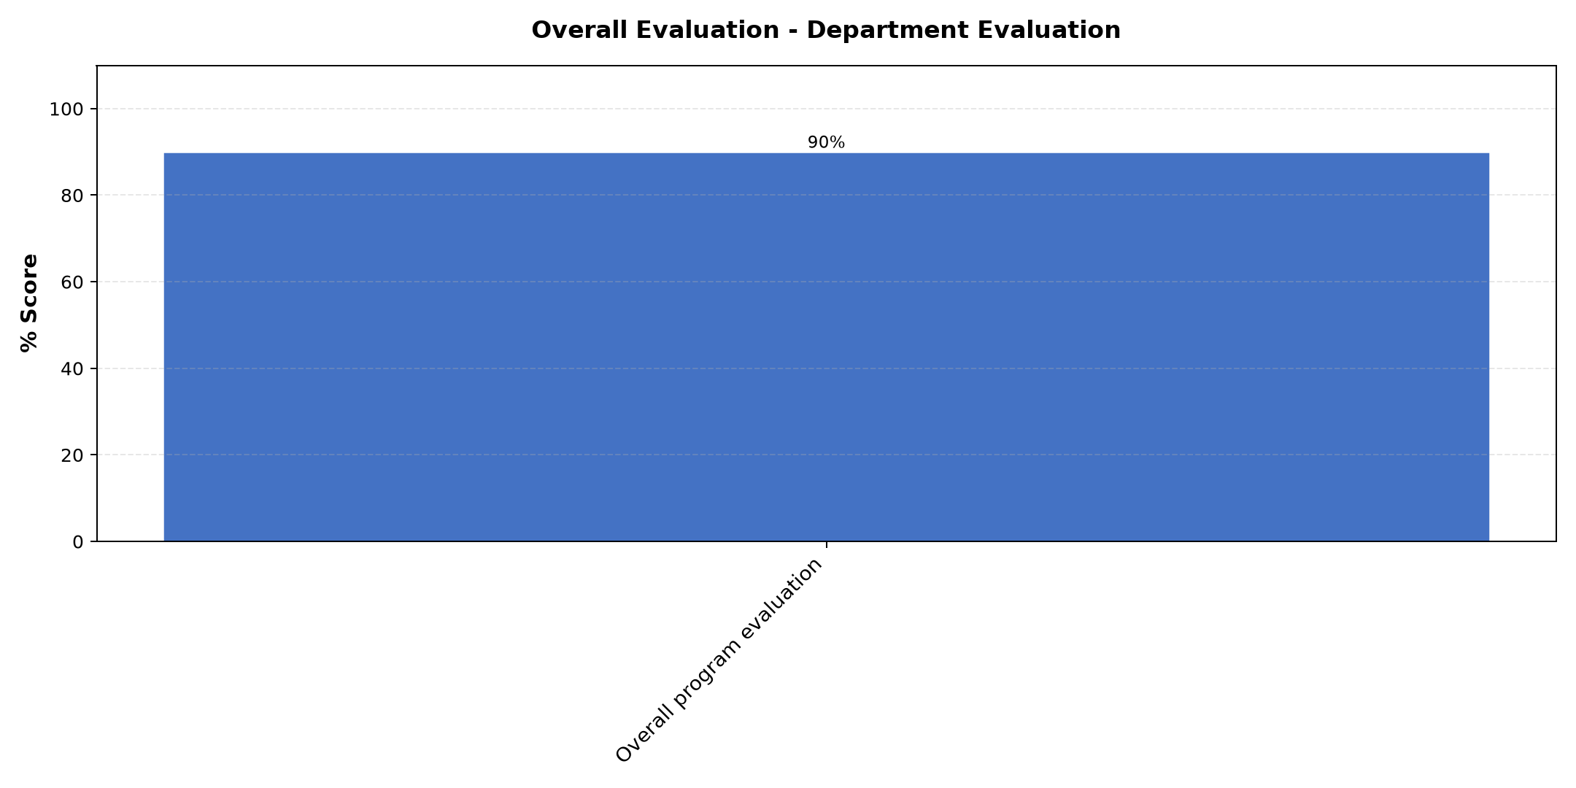

Comments & Feedback
No comments recorded.

Program Manager (Matilda Biira)
Evaluation Parameter | (%) Score
Punctuality (Commencement and Completion of Sessions) | 70
How well do you understand the core concepts presented? | 80
Rate your confidence in applying the new skills learnt | 70
Degree of Faculty preparedness for the sessions | 70
Content and methodology of the program | 70
Average score | 72

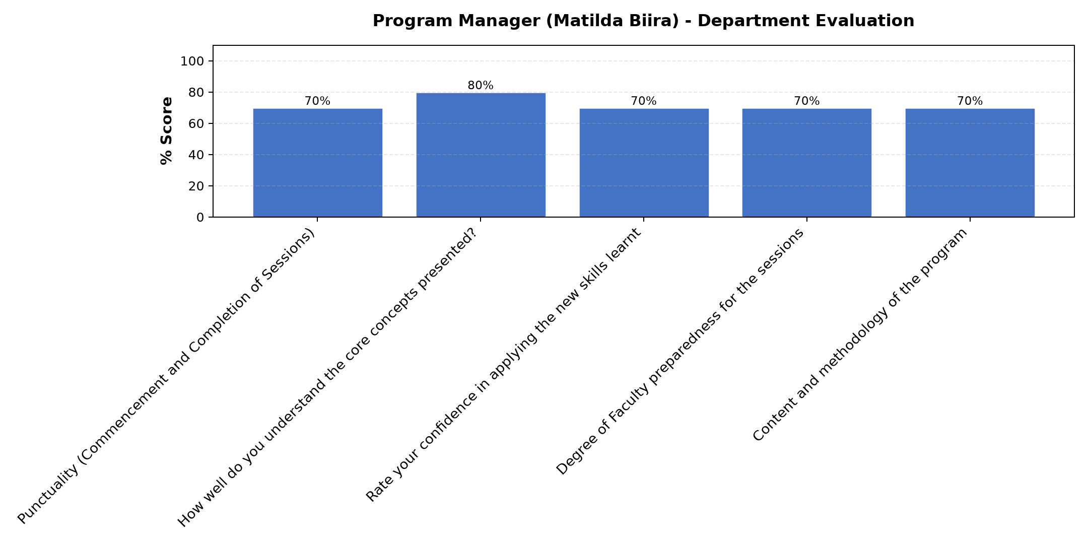

Comments & Feedback
- • Maltida thank you for your commitment

What attracted you to the programme??
Evaluation Parameter | (%) Score
Punctuality (Commencement and Completion of Sessions) | 100
How well do you understand the core concepts presented? | 100
Rate your confidence in applying the new skills learnt | 100
Degree of Faculty preparedness for the sessions | 100
Content and methodology of the program | 100
Average score | 100

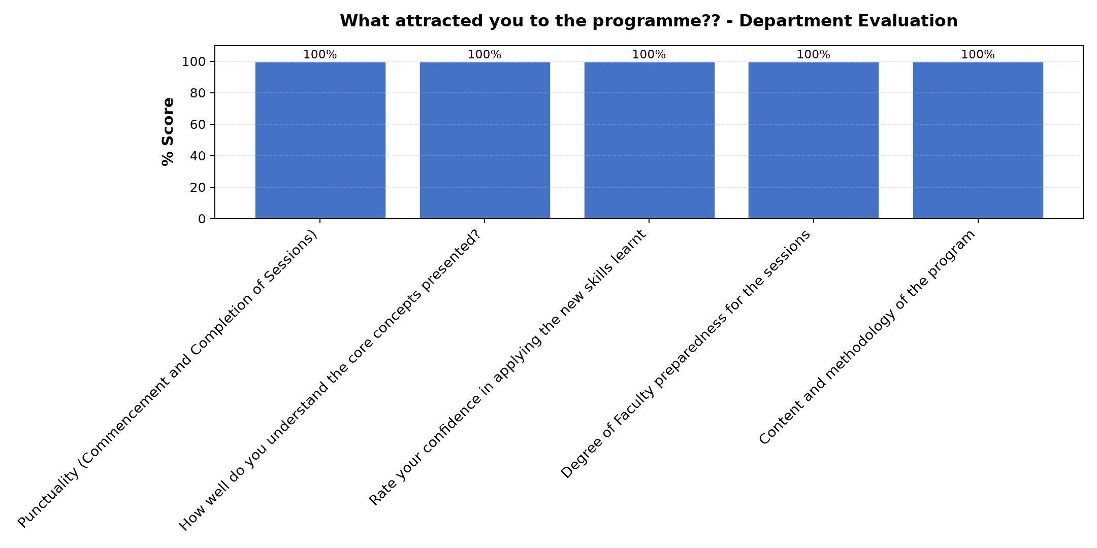

Comments & Feedback
- • Self awareness
- • Commitment of Strathmore

What topic would you recommend being expanded/improved in this programme’s units?

Comments & Feedback
- • How social enterprise is connecting us back to our charisms
- • Business plan

Which areas in this programme did you find most important to your social enterprise?

Comments & Feedback
- • Social enterprise planning because some times we do things with out planning which is not good
- • Reflection on whether our social Enterprise are still on the our charism

Which teaching methods applied in the course did you enjoy/learn from the most?

Comments & Feedback
- • Sharing and discussing from different participants
- • Group interraction

